URL | social-media-guide-for-businesses
Title | The Simple Guide to Social Media for Business
Meta Description | Which Social Media Platform should you choose? This guide helps you to assess different platforms and take the right decision that benefits your business.
Headline | Which Social Media Platforms Should you use for Your Business?
Reading Time | 16
Level | Beginner
Category | Digital Marketing
Teaser | This Beginner Guide gives you an overview what Social Media Platforms you should possibly be at as part of your Digital Marketing Strategy in 2021!

The Simple Guide to Social Media for Business

The effect social media can have on your business is no longer a debate. In order to successfully build an engaged customer base, correctly utilizing social media is not just a plus, but actually a necessity.
In fact, as of July 2020, for the first time more than half of the world are active users on social media. With over half of the world active on these platforms, they should be used as a tool for your business to attract new customers and communicate with current ones.

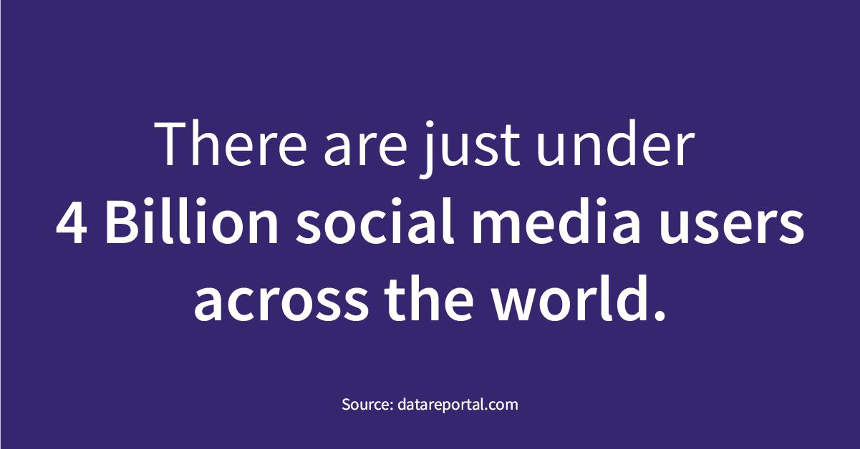

Number of Social Media Users worldwide

In fact, 92% of marketers say that social media has helped their brand increase exposure, but how do you actually go about using social media for your business? Getting started can be difficult, especially when organic growth can be slow to begin with. Here we would like to point you to another exciting article on the Link to Article 1000042, which might add value to your research.

And how do you even know what social media platforms to use? With so many to choose from, what’s the best strategy for you to take?

Overview of Social Media Channels

There are hundreds of social media networks out there, each of which serves a unique purpose and holds a unique type of person. Because of this, it’s important to understand that you will get a better return on your efforts by focusing on the platforms that have the most traffic and are relevant to your audience.

Don’t spread yourself too thin by trying to master every social network. It’s much better to be the go-to brand in your niche on Twitter, then to be mediocre across 5 different platforms.

The most popular social media channels by users are:

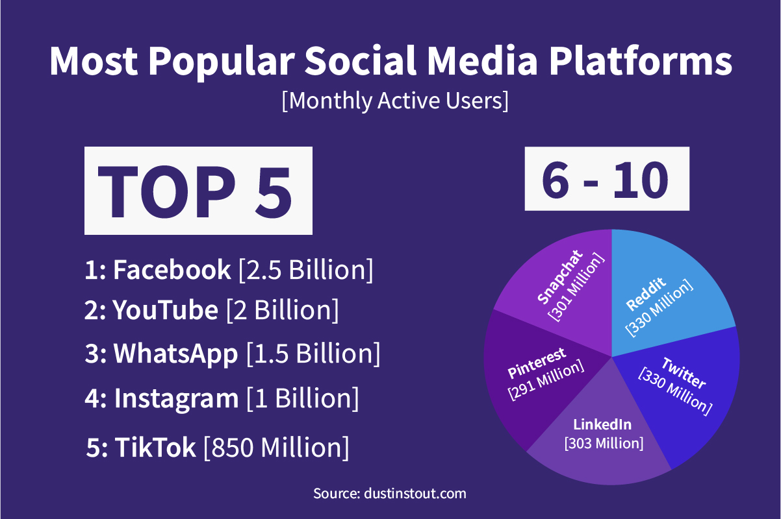
Most popular Social Media Platforms

But how do you go about choosing the right social media platforms for your business?

The Two Components of Choosing the Correct Social Media Platforms

1: Audience Research
The first step of choosing what social media platform to use for your business, is by researching the demographics of your current audience. This can be done in three ways, depending on what type of business you are.

1: Talk to Your Team Members
The first way to see who your average customer is, is by asking your sales team, support team, and any other teams in your business that deal with customers.

Ask them what the age and gender is of the average customer they serve. What are their general interests? Are they parents? Where do they live? Etc.

Your team members should know basic information of the average person they see every day off the top of their head.

Maybe your marketing or management team has already done a strategic customer segmentation that you can use to see the data on your current visitors and customers. Ask yourself: Do these profiles match with the feedback from your sales and customer support team?

2: Check Your Analytics
A more reliable way of checking the characteristics of your current audience is by checking the analytics on your website.

To do this, log into your Google Analytics account, go to ‘Audience’ -> ‘Demographics’.

If you don’t have Google Analytics installed for your business, read our in-depth guide on why you need it and how to set it up here. Once on demographics, you will see a dashboard like this:

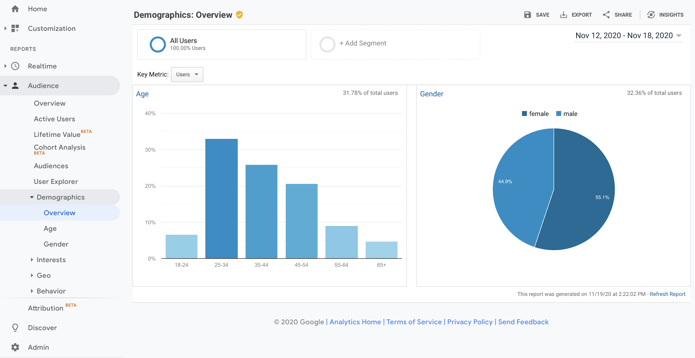

Google Analytics for User Demographics

As you can see from this example, the majority of website visitors are female, and between the age of 25-34. This information will be vital to choosing the correct social media network for your business, as I’ll show you later.

Checking your analytics is important to do in addition to talking to your team members about your offline customers. Just focusing on your real-life customers may give you a good insight to the customers that step foot inside your store, but what if none of these people use social media? Using their demographics to plan your social media strategy would be useless. You want to make sure your social media strategy is aligned with your audience that is actually active on these platforms.

This is where using Google Analytics comes in handy. Chances are if someone is browsing your website online, they will also be active on some form of social media channel. You want to choose your social media platforms based on the target audience that is actually active online.

3: Analyze Your Product or Service
Your target customer can become self-explanatory by just simply looking at the product or service you are offering. Does your business sell a SaaS in a B2B market? LinkedIn may be your best bet.

Or do you sell kids toys? Maybe a social media platform full of parents with young kids, such as Pinterest is better for you.

Generally speaking, Facebook, Instagram, and Pinterest are best for e-commerce brands. LinkedIn is best for companies in the B2B market. TikTok, Snapchat, Instagram, and potentially Twitter are best for targeting those aged 16-24.

Even if you’re a brand-new company, and don’t have any customers yet to base any information from, just look at your product and ask yourself what audience is going to be the most interested in this!

2: Content Strategy

After you’ve completed the audience research, you also need to ask yourself ‘what type of content am I aiming to put out?’ Is it going to be educational videos? Perhaps YouTube is your best bet, and then you could repurpose the videos for other channels such as TikTok and Facebook.

Or are you a funky restaurant that wants to put out fresh images of their amazing looking food? Head for a photo sharing app like Instagram.

Here is a list of content you may be considering putting out:

- Blogs
- Photos
- Fun videos
- Educational videos
- Infographics
- Case studies
- Memes
- Product reviews
- Live videos
- Q&As
- Interviews

You can already see from this list that there are many different types of content that you may consider sharing with your audience. Some social media channels will suit certain types of content more than others.

For example, if you’re going to focus on memes, you’d be best sticking to Instagram and Twitter, and avoiding LinkedIn. This is because LinkedIn is used by business professionals, who don’t use the app to see memes. If these professionals do want some entertainment during their lunch break, they’ll launch Instagram or Twitter instead.

On the contrary, if you are going to be creating interviews, Q&As, and other insightful content, LinkedIn may be a great platform for you. This is because users of LinkedIn use the app to help them progress professionally.

Along with your content strategy, you should also think ‘what purpose am I using social media for?’ Is it to entertain? To build a personal brand? To build your blog traffic? To get more customers for your new start-up?

Answering all these questions is vital before selecting which social media platforms to execute your content strategy on. We’d recommend differentiating content slightly based on the social media channels you are using. This is because, as mentioned, they may have slightly different audiences that like to see slightly different types of content.

For example, someone on TikTok is looking for a short, to-the-point video whereas someone on YouTube may be looking for a longer, more in-depth video.

A great tip is to use the content for social channels and transcribe it into blog posts for your website to help boost your organic rankings in the search engines. Another great idea is to do some keyword research on the topics you are planning to write about. This will give you an idea of what’s most sought with your audience and how competitive those content areas are.

Choosing Your Social Media Platforms

Now you should know what demographic your target audience is and have your content strategy at the front of your mind, so it’s time to choose the right social media platforms to begin sharing your content on.

For a rundown of the top 8 social media platforms, and how your business can use them, read our in-depth guide here. Use this guide, along with the customer and product research you completed in step 2, to help gauge your social media strategy.

Remember that social media isn’t about shouting your brand's name everywhere. It’s about choosing the right audience to build a relationship with.

How to Use Social Media

This will depend on the platforms you are using, but as a general rule of thumb, here are the four benefits of using social media for your business.

To Expand Your Audience
The first and most obvious reason that brands use social media for is to expand their audience. The most sustainable way to achieve this is simply by consistently putting out high-quality content.

If you are stripped of time and resources, and you are struggling to produce the content needed, one thing you can do is make a long form piece of content and repurpose it into different formats for different social media channels. For example, you could make a 20-minute-long YouTube video, and that video could be cut down into multiple shorter videos that can be distributed through TikTok, Instagram, LinkedIn, Facebook, etc.

Your main aim should simply be to focus on putting out content every day. The consistency will not only be favorable to the algorithms of these platforms, but also will help you expand your audience. The more content you put out, the more people will see it, the more shares it will get, and the more followers you will attract.

To Build Relationships with Your Customers
Using social media to engage with your audience is key to building business success.

Customers spend 20%-40% more money with companies that actively engage and respond to customers via social media.
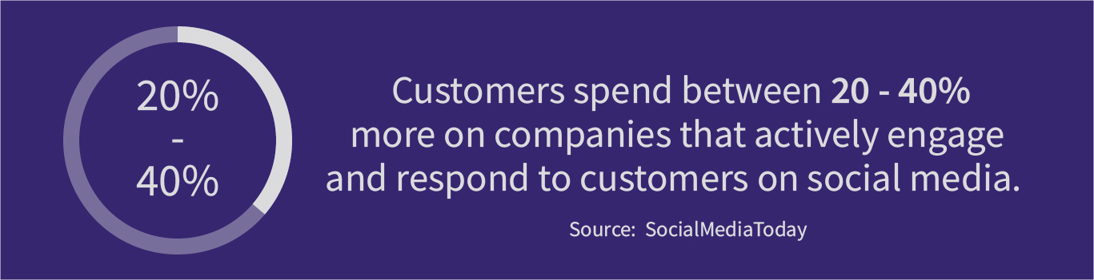

Customer Relationship Management (CRM) on Social Media

This is because customers value when they are treated like people rather than a number. Therefore, at Marketing Monkeys, we have created data driven software and databases that help businesses to create personalized and targeted marketing campaigns, specifically designed to improve customer relationships.

The perfect way to build relationships with social media is to simply have conversations. Reply to your comments, direct messages, and other communications with your brand. Even if the message isn’t directly towards your social media account, if you see people talking about your company online, feel free to jump in and say thank you and build a conversation with them.

Establish Your Brand as an Authority in Your Niche

This is one of the best ways your business can use social media. To establish your brand as an authority, you want to focus on the quality of your content. In particular, you want to aim to publish educational content that teaches people something or makes their life better in any way.

For example, if you produce a social media management software, producing lots of content around the benefits of social media can help your business appear as an authority in your niche. No matter the channel, or even whether your marketing is focused online or offline, your visitors should always understand your niche in your marketing messages.

No matter what your niche is, find a way in which you can use your social media platforms to make you appear as an authority. Even if this isn’t the way that your customers find your brand, 75% of customers still use social media research as part of their buying process. This means that three quarters of your paying customers will have used social media to help them decide which website to buy their desired product from.

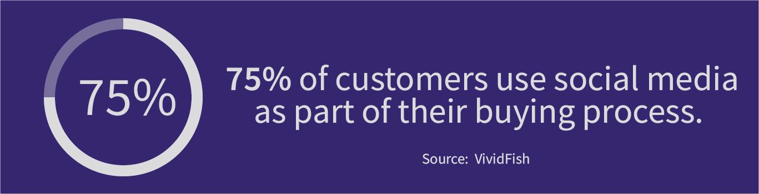

Social Selling - Social Media as part of the Buying Process

If people view you as an authority in your niche, they will be more likely to buy from you as great content and posts improve your brand experience and credibility.

To Improve Customer Service

The way brands provide customer service has changed over the last few years. For many, social media is now one of the main ways to solve customer queries.

In fact, 1 in 3 customers now turn to social media to ask for advice from companies. The way your business can use social media to improve your customer service is to be active, and fast replying. 69% of customers believe fast resolution is vital to having a good experience with a brand.

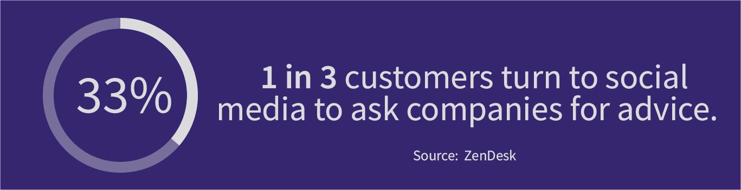

Customer Service on Social Media

Most companies use Twitter and Facebook as ways to deal with their customer queries as it’s super easy to communicate on, and these are where the majority of customers go to contact a brand.

Make sure either you, or someone in your team, is reviewing the comments on your social channels constantly throughout the working day.

Key Takeaways

Because social media is so popular nowadays if you don’t use it you will simply lag behind your competition. Social media is no longer just used for pleasure and mindless browsing but is used by customers to do product research before committing to a purchase.

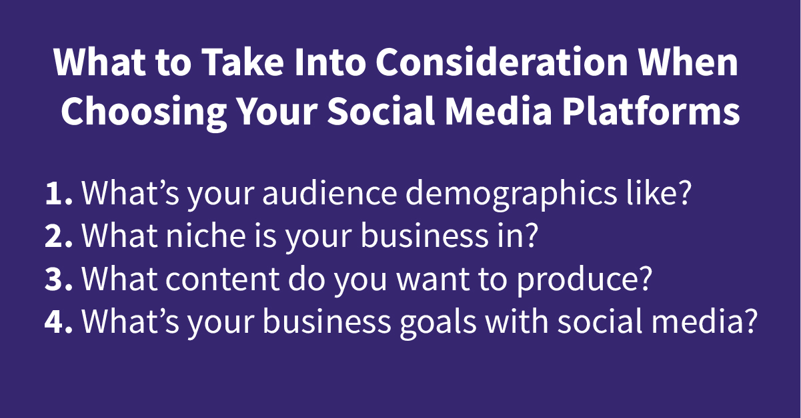
Tips how to choose the right Social Media Platform

If you would like help with arranging a social media strategy, get in contact now for a free consultation with one of our experts.

